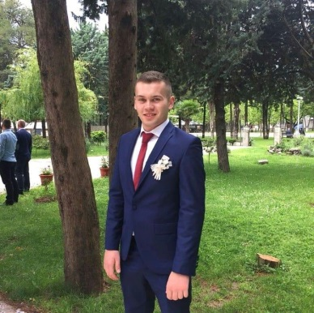

**SVETOZAR**

**BRBORIĆ**

Software Developer

**DETAILS**

**Contacts Nationality**

Dr. Ivana Ribara 5, Novi Sad, Serbia Serbian

[svetozarbrboric@gmail.com](mailto:svetozarbrboric@gmail.com)

+381644094513

**Date / Place of birth**

22.01.1999

Ljubinje, Bosnia and Herzegovina

**LINKS**

<https://github.com/Svetozar99/ProjekatEObrazovanjeFTN.git> - Student service

<https://github.com/Svetozar99/PoslovnaIformatikaProjekat.git> - Warehouse managment

<https://brboricsvetozar.000webhostapp.com/> - My personal site

**EDUCATION**

**Faculty Of Technical Sciences, Novi Sad**

I enrolled at the Faculty of Technical Sciences in 2018. While studying I developed various desktop and web

applications. I think I made the right choice, because since then I’ve been learning new things and it gives me

a chance to meet new and interesting people with who I can exchange experience, learn from and even

work with!

**SKILLS**

**HTML & CSS**

**Spring boot**

**AngularJS**

**C#**

**Android**

**JavaScript**

**MySql**